TELEMEDICINE VISIT PREPARATION INSTRUCTIONS

Please review the following information before you join your telemedicine visit, and sign at the bottom. Please contact your provider before your visit with any questions. Thank you!

Q: What is a telemedicine visit?
A: A telemedicine visit is an appointment with your provider that is conducted through video technology. These appointments are also known as remote visits, video-chat consultations, remote sessions, telehealth visits, and virtual care encounters.

Telemedicine visits are an effective means for continued care during a time of isolation or inability to leave home. They are additionally valuable to anyone who has impaired mobility, for those who are sick, or those who have non-acute health concerns.

Instead of coming into the office for your appointment, you stay home and use your computer, laptop, or mobile device to see and talk to your provider.

Q: How do I pay for a telemedicine visit and what will it cost?
A: Payment in full is expected before you begin your telemedicine visit. Failure to remit payment will result in cancellation of your telemedicine visit, and you may be charged in accordance with the cancellation policy. Payment may be rendered online via MasterCard or Visa to a secure PayPal account. Your provider may send you a PayPal invoice, or you can remit payment via PayPal online.

To remit payment, use this secure PayPal link: https://paypal.me/DrCindyTherouxJette

When you click this secure link, you will be directed to a secure PayPal page that looks like this:

Enter the fee for your telemedicine visit.
Remit payment with your Mastercard or Visa card.

Fees:
Telemedicine follow-up visit (existing patients only): $100.00.
Initial telemedicine visit (new patients, and patients who have not been seen in over one year): $155.00.

Q: Where can I have a telemedicine visit?
A: You should join a telemedicine visit from a private, quiet, and well-lit location.

Make sure that you are alone and no one will over hear the confidential conversation you will have with your provider, and make sure you are in an environment that is free from distraction and interruption. You may be asked to demonstrate exercises and movements so make sure to be in a place that has space to move around if necessary.

You may also want to wear a headset or headphones if you have them, as this will help cut down feedback sounds and echoing. Try to make sure there is no background noise that may interfere with your conversation.

Make sure there is plenty of lighting so that your provider can see you.

Q: Do I need to bring anything to a telemedicine visit?
A: Come to the appointment with the mindset you would have as if you were going to your provider’s office. If it is your first telemedicine visit, please have your list of current medications and supplements with you.

You may also want to have a pen and paper, and any notes or questions for your provider that you would typically take to your in-office visit. If you are using a computer or laptop for your visit, keep your landline phone or mobile phone nearby so that your provider can call you to continue the visit in case of disconnection.

Q: What should I expect with a telemedicine visit?
A: During your telemedicine visit, you will use the camera and audio on your computer, laptop, or mobile device so that you can see and talk to your provider, and so they can see and hear you. If you have used other video-call platforms like Skype or FaceTime, this will feel familiar.

Unlike those applications, however, your provider’s system is HIPAA-compliant, encrypted, and secure to protect your privacy. This means that your conversation is protected in order reduce the risk of a third party breach.

Telemedicine visits are very similar to in-office visits. During a remote session, your provider will move through a typical in-office visit, but will address your concerns via telephone or through a live audio-video call.

You will receive the same guidance you receive in-office; it will be tailored for you in order to help you prevent illness, recover from illness, or to maintain a state of wellness and support your optimal health and function.

Your telemedicine visit may include any of the following:

- Lifestyle counseling
- Prescription of herbal medicine formulations (which can be shipped directly to you)
- Instruction in self acupressure
- Education in stress management and stress reduction techniques
- Exercise and diet recommendations
- Guidance in meditation practice

And as always, you and your provider will simply connect in supportive conversation.

Q: Do I have to consent to a telemedicine visit?
A: You will be expected to sign a telemedicine visit consent form before you attend your telemedicine visit. Your provider will send this to you in advance, and it will be available on the patient portal.

Q: How do I join a telemedicine visit?
A: An invitation to join a telemedicine visit is sent by email from your provider. The email includes a special link that will allow you to join the visit. The email invitation for you to join your telemedicine visit will look like this:

To join your telemedicine visit:
- Click the link in the email that says:

You will automatically be directed to a Telemedicine Video Call website that looks like this:

Next, you will need to allow access to your camera and microphone. Click “Allow”.
This is necessary for you and your provider to see and hear each other. If you do not allow access, the telemedicine visit will end and will not be able to be conducted.

If you are using Safari as your web browser, the request for access will look like this:

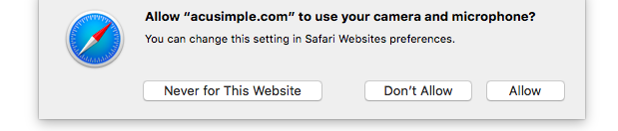

Success!
Once you have allowed access to your camera and microphone, you will be directed to a page that asks you to wait for your provider to connect and join you. It will have a video screen and will look like this:
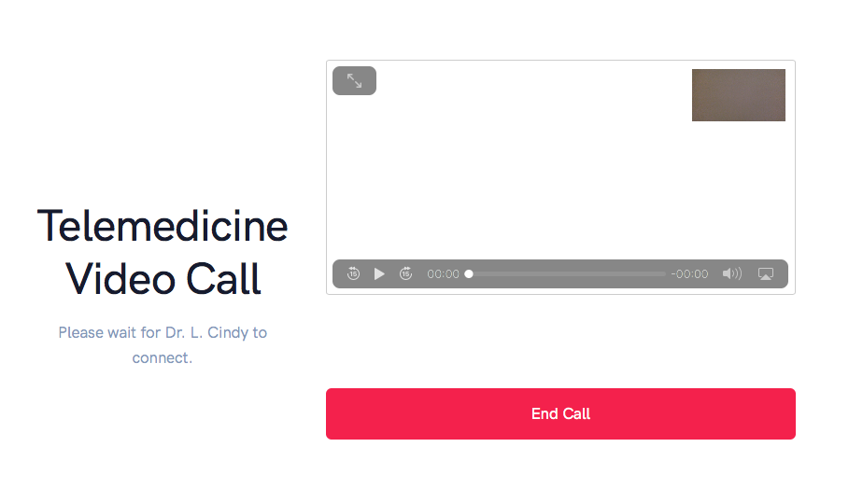

Q: How will the telemedicine visit be ended?
A: When the telemedicine visit has concluded, your provider will end the call and you will see a screen that informs you the visit has ended.

Upon completion of your telemedicine visit, the screen will look like this:

TECHNICAL QUESTIONS AND TROUBLESHOOTING TIPS

Q: What technology do I need for a telemedicine visit?
A: You will need a mobile device, a computer, or a laptop to attend your visit. A telemedicine visit with your provider at Acupuncture and Integrative Medicine Associates of Nashua, PLLC requires no special downloads or additional computer software, and there is no need to install anything.

Be sure to check the battery charge on your device to ensure you have plenty of power. Have the power cord nearby just in case. If you’re not sure if the charge is sufficient for the length of the visit, plug in your device.

The device will need to have a functioning front-facing camera and a functioning microphone. It is recommended that you test your camera and microphone in your Settings / Control Panel to see if they are functioning properly before your telemedicine visit. You can also test them by using Skype or FaceTime.

Q: Do I need to be on a wireless network to attend a telemedicine visit?
A: A strong Wi-Fi Internet connection is recommended for best quality video and audio. A strong connection is important to ensure that you and your provider can see and hear each other. If you do not have access to a strong Wi-Fi signal, you may use your cellular data to participate in a telemedicine visit. Cellular data rate charges from your carrier may apply if you use cellular data.

Q: Are certain web browsers better than others for telemedicine visits?
A: Chrome is recommended for best performance, but you can use other browsers, such as Safari or Firefox. Browser version updates are available periodically, and for best performance it is recommended that the browser you are using is up to date and running the most current version.
Q: Can I shut off the video and use audio only call during a telemedicine visit?
A: Audio-only calls are not an option on the telemedicine platform. If there is an issue that causes video or audio failure, the telemedicine visit will end. Both elements need to be working in order for the system to function.

If you are using a computer or laptop for your telemedicine visit, please keep your landline phone or mobile phone nearby so that your provider can call you in order to continue and complete the visit.

Q: What device provides the best experience when attending a telemedicine visit?
A: All devices are acceptable and compatible with the telemedicine platform. It has been tested extensively with both Apple and Android mobile devices, and with PC and Mac computers and laptops.

Performance quality is related to meeting specific technical requirements, such as having an up to date browser, having adequate internet connection and speed, and having a functioning camera and microphone on the device.

Q: How fast does my internet speed need to be for a telemedicine visit?
A: You will need to have a good internet connection with speeds of at least 10Mbps. It is recommended you test your internet speed before you join your telemedicine visit. You can use Google to check your internet speed by typing "internet speed test” into the Google search bar.

Q: What are the specific hardware requirements for a telemedicine visit?
A: More available RAM and newer computers/devices are better in terms of hardware. The list below includes operating systems and browsers that will adequately support a telemedicine visit.

The numbers signify the minimum version of the operating system or browser that is required to support the telemedicine visit. For example, Chrome 26+ means using a version of Chrome that is version 26 or greater will support a telemedicine visit.

- Mac or PC
- Microsoft Edge 12+[26]
- Google Chrome 28+
- Mozilla Firefox 22+[27]
- Safari 11+[28]
- Opera 18+[29]
- Vivaldi 1.9+
- Android
- Google Chrome 28+ (enabled by default since 29)
- Mozilla Firefox 24+[30]
- Opera Mobile 12+
- Chrome OS
- Firefox OS
- BlackBerry 10
- iOS
- MobileSafari/WebKit (iOS 11+)

PRINT PATIENT NAME:_______________________________________________________________
RELATIONSHIP TO PATIENT (self, guardian, etc.): _________________________________________
GUARDIAN NAME (if applicable):________________________________________________________
DATE: _____________________________________________________________________________

I have read and understand the above information, and I will contact my provider prior to my telemedicine visit for clarification if necessary.

SIGNATURE:________________________________________________________________________

